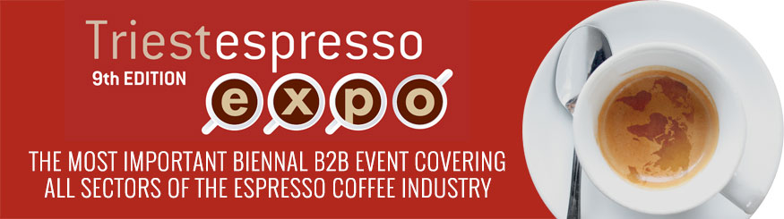

TRIESTESPRESSO: WITH VANILLA, RICOTTA, NUTELLA AND PISTACHIO AND WITH CHILLI AND DARK CHOCOLATE, THESE ARE THE PROPOSALS THAT WON THE COMPETITION "GIVE FLAVOUR TO YOUR COFFEE" BY FIPE
The ex aequo winners - Lino Alberini from Parma, Stefano Massimino from Milan and Fabrizio Goffredo from Rome - were awarded by the Chairman of the Chamber of Commerce of Venezia Giulia Antonio Paoletti and by the Managing Director of FIP’E, Rodolfo Citterio

The winners of the competition "Give flavour to your coffee", launched by Fipe - Italian Federation of Public Businesses and Triestespresso to stimulate the imagination of operators to look for new products in line with the new trends of consumers increasingly fascinated by the exotic flavours of the world of spices, were awarded Saturday 27th October. Preparing a spicy coffee is the challenge taken up by many, even proposing sophisticated recipes with the use of rare ingredients such as the new "Irish coffee" perfumed with rosebuds or the long drink with citron, lime or mint combined with coffee.
The evaluations of the master of spices Marco Savona of James 1599 and the expert roasters of Mondi Caffè in Rome led to the choice of three recipes that, according to the experience of retailers, best meet the tastes of consumers. The choice was difficult and led to the selection of three ex aequo top places.
These are "Vanilla", the new vanilla espresso coffee offered by Lino Alberini of Parma; "Etna", a coffee based on ricotta, Nutella and pistachio with Sicilian cannoli wafer and espresso, created by Stefano Massiminoof Milan; and a "Chilli and dark chocolate" coffee presented by Fabrizio Goffredo of Rome.
The winners were awarded Saturday 27th October, at the Hydrodynamic Power Station, the heart of the Triestespresso Expo events, by the Chairman of the Chamber of Commerce of Venezia Giulia, Antonio Paoletti, and the Managing Director of the National FIPE, Rodolfo Citterio.
In addition to the tasting of the Sicilian Ammu espresso cannoli, many tastings were held during the event and other coffee recipes were tried out, offered by Mondi Caffè and Cosmai Caffè.

