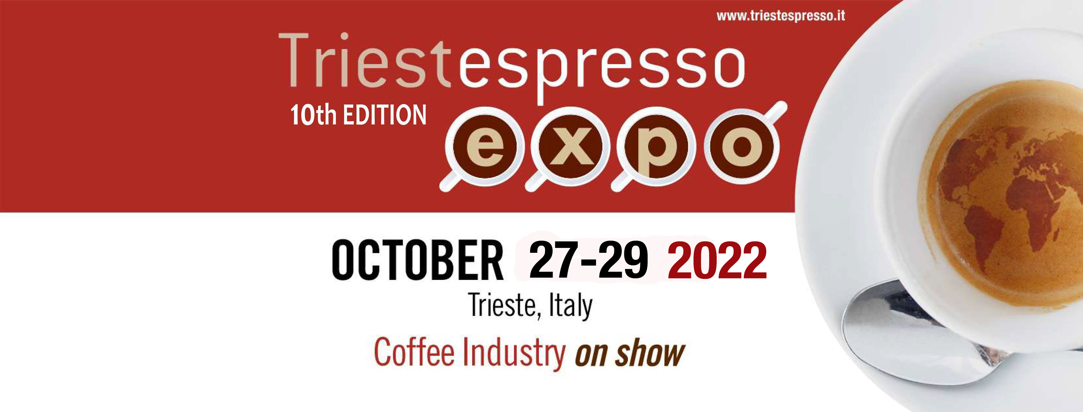

10th EDITION
organised by realized by partner
TRIESTESPRESSO EXPO CONFIRMS THE DATES 27-29 OCTOBER 2022
THE EVENT WILL TAKE PLACE IN THE BRAND NEW TRIESTE CONVENTION AND EXHIBITION CENTER

TriestEspresso Expo confirms the dates for 2022. The biennial fair dedicated to sector professionals will take place from October 27th to the 29th and remains the most important international event dedicated to the entire coffee production chain.
TriestEspresso Expo, organized by Aries scarl-Chamber of Commerce Venezia Giulia, in
collaboration with the Associazione Caffé Trieste, will take place in the Porto Vecchio (old port) of the region Friuli Venezia Giulia’s capital, within the new and modern Trieste Convention and Exhibition Center, set among the evocative warehouses of the old port of Trieste, the city’s ancient harbor port.
The tenth edition will mark the occasion for the sector to start afresh after the two year hiatus caused by the Covid-19 pandemic. We are already working on a programme of high level collateral events, dedicated to the most current topics and with the participation of international level experts.

TriestEspresso Expo is an event exclusively dedicated to a public of international professionals, featuring an exhibition area of around 200 exhibitors showcasing some of the key brands in the sector.

TRIESTE COFFEE CAPITAL IS NOT ONLY A REGISTERED TRADEMARK, BUT ALSO
A TANGIBLE PRODUCTIVE AND SOCIAL REALITY, PERFECTLY MIRRORED
IN AN INTERNATIONAL FAIR LIKE TRIESTESPRESSO EXPO. THEREFORE, WHY TRIESTE?

BECAUSE OF LOGISTICS
- Trieste is a small city, everything is within a short distance from the seat of the fair, no need for long transfers.
- Trieste offers a wide choice of hotels, suitable for all budgets.
- You can reach Trieste in many ways, by plane, train, and car and once in the city, you can move around easily on foot or short cab rides.
- In Trieste shops and restaurants, bars and cafés all within reach and offer a broad range of meal options.
- In Trieste, after a long day of work you can wind down by walking along the sea, right in the center of the city and enjoy the view.

BECAUSE OF KNOW HOW
- Trieste has been importing, processing, brewing and drinking coffee since 300 years.
- Trieste hosts top level courses dedicated to the economic and scientific aspects of coffee and several sector companies offer training programmes (brewing, tasting…).
- Trieste is aware of the economic impact the entire espresso coffee chain can have on the development and growth of a wide range of businesses (importers/distributors, roasters, sellers, cafés/bars and restaurants).
10th EDITION
organised by realized by partner
BECAUSE OF SPECIALISATION
- Trieste mirrors the spirit of the fair, contained, but highly focused on brand recognition and credibility
of results.
- Trieste brings the entire espresso coffee chain under one roof, for 3 days of full immersion in a
top rate business environment of specialized worldwide companies.
- Trieste is hosting the 10th edition of this biennial fair, tangible proof of the ongoing and growing
interest towards our event.
- Trieste has always understood that B2B events mean …business! Top rate exhibitors and professional
visitors focused on the best possible deal.
BECAUSE OF TRADITION
- Trieste lets you experience the pleasure of excellent coffee even outside the fair grounds, from
world famous fascinating historical cafés to the smallest local hangout.
- Trieste lets you discover new ways of preparing coffee, there are over 50 ways to serve coffee in
our city!
- Trieste’s café culture has been a constant of the city’s habits, with famous writers and intellectuals,
sitting side by side with students and workers, all sipping their favourite blend.
- In Trieste, coffee is ultimately about people, a match made in heaven between those who make
coffee and those who drink it!

Trieste, Italy 17/03/2022

Press office Triestespresso Expo
dott. Andrea Bulgarelli
Camera di Commercio della Venezia Giulia
Gabinetto di Presidenza
Relazioni Esterne, Comunicazione e Ufficio Stampa
Venezia Giulia Chamber of Commerce
President's Cabinet - Communication, External Relations and Press Office
Tel. +39 040 6701264
Mob. +39 335 7824405

